Chapter 10, Problem 35.

Calculate I_{o} in Fig. 10.30 (for Practice Prob. 10.10) using mesh analysis.

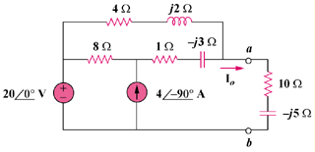

Figure 10.30
For Prob. 10.35.

